

|  |  |
| --- | --- |
| **Ambrose Treacy College Blogging Website** | |
|  |  |
| **27/08/2023**  **NATHAN PERRIER**  **AMBROSE TREACY COLLEGE** |  |

Table of Contents

Explore 2

Problem Description 2

Development Platform 2

Project Scope 3

Mind Map 4

Development Platform **Error! Bookmark not defined.**

Existing Solutions **Error! Bookmark not defined.**

Develop 5

Wireframe 5

Data - Variable Table 6

Dataflow Diagram 7

Game Object Map **Error! Bookmark not defined.**

Pseudocode **Error! Bookmark not defined.**

Pseudocode **Error! Bookmark not defined.**

Generate **Error! Bookmark not defined.**

Evidence of User Interface **Error! Bookmark not defined.**

Evidence of Code **Error! Bookmark not defined.**

Evaluate **Error! Bookmark not defined.**

Testing **Error! Bookmark not defined.**

User Testing **Error! Bookmark not defined.**

Criteria **Error! Bookmark not defined.**

Impacts **Error! Bookmark not defined.**

Usability recommendations **Error! Bookmark not defined.**

Accessibility checklist **Error! Bookmark not defined.**

Additional Evaluation **Error! Bookmark not defined.**

Risks Taken **Error! Bookmark not defined.**

What Was learnt **Error! Bookmark not defined.**

Improvements and Limitations **Error! Bookmark not defined.**

Real-World Application **Error! Bookmark not defined.**

References 15

Appendices 16

# Explore

## Problem Description

* Ambrose Treacy College is an all-boys school located in the Brisbane area who has requested a website.
* The Senior English department requires a writing platform for their blogging project. You are required to build a prototype blogging website application.
* This application should allow a user to log in and create a blog post.
* These blogs posts should then be viewed by other site members and the teacher.
* The website should also allow the login of an administrator (teacher) with extended privileges.

## Development Platform

* To develop the final products multiple languages could be used.
* The languages chosen for this project are; Python (backend), JavaScript (frontend + backend), PHP (backend), SQLite (backend (database)), HTML (frontend), CSS (frontend), SCCS (frontend), Bootstrap CSS (frontend)
* Some of the libraries used in this project are; SQLAlchemy, Flask, Bcrypt, OpenAI, Flask Login, PIL, Google Maps, and more.
* The amalgamation of these languages and libraries should produce the final product.

## Project Scope

* Deadlines:
  + Draft Deadline: Week 8, Term 3
  + Final Deadline: Week 2, Term 4
* The Device used is adequate and has the necessary libraries and languages installed
* The website will be developed for the popular web browsers

# Development Platform

|  |  |  |  |  |
| --- | --- | --- | --- | --- |
| PRESCRIBED CRITERIA | | | SELF-DETERMINED CRITERIA | |
| PC1 | Develop a website with many pages and features | | **SDC1** | Using objects to code in a modular way |
| PC2 | Allow multiple users to use the website and have the ability for new users to be added | | **SDC2** | Using lists, arrays, and dictionaries to store data |
| PC3 | Use databases for data storage | | **SDC3** | Allow users to upload and customise their profile picture |
| PC4 | Create a folio that outlines the user interface and coded components of the solution | | **SDC4** | Use authentication codes to confirm user authenticity |
| PC5 | Have blog functionality that all users, can use, view and access | | **SDC5** | Send emails to users to send necessary information |
| PC6 | Generate a user/visual interface | | **SDC6** | Use JS for data handling and design elements |
| PC7 | | Incorporate the use of the client’s signature colours or logo | **SDC7** | Allow the users to reset their passwords if forgotten |
| PC8 | | Integrate security features such as hashing and encryption | **SDC8** | Develop and use the Lowenstein distance algorithm |
| PC9 | | Users must be able to edit or delete their information | **SDC9** | Integrate a spell check in the blog functionality |
| PC10 | | Have admin functionality that is given to the client’s staff. They should be able to edit, delete and add user and blog data. | **SDC10** | Have nested comments for blog that users can edit and delete |
| PC11 | | Allow for users to login, signup and logout | **SDC11** | Use SQLAlchemy and a multi-file architecture for the code design |
|  | | | **SDC12** | Use CSS to style the website to adhere closely with the client’s style |
| **SDC13** | Use animations on the website to engage the user |
| **SDC14** | Prioritise website responsiveness to improve accessibility |
| **SDC15** | Have a like-dislike system for blogs and comments |
| **SDC16** | Use AI to generate blog images if the user has no image to upload |
| **SDC17** | Have a social system where users can follow/unfollow other users |
| **SDC18** | Develop a notification system where user’s will be notified when they are followed or a user they are following uploads a blog |
| **SDC19** | Have an AI to suggest words or sentences as the user is typing |
| **SDC20** | Have an AI to generate blog titles or descriptions |
| **SDC21** | Allow for user’s to add tags or categories to their blogs to allow to inform readers and add context. This will also be used for the search feature |
| **SDC22** | Allow users to search for blogs or users |
| **SDC23** | Have a featured blog section were the blogs with the most likes or engagement (number of comments) will appear |
| **SDC24** | Allow users to achieve their blog posts or save as a draft when creating one |
| **SDC25** | Use drone footage of the Client’s campus to engage users when they click on the website |
| **SDC26** | Have terms and policies regarding the use of the website. Make users agree to these terms before signing up |
| **SDC27** | Have multiple pages regarding information about the client such as subjects or their relation to EREA |
| **SDC28** | Have a contact form where users can ask questions |
| **SDC29** | Have a newsletter where users can sign up and receive newsletters |
| **SDC30** | Have unit tests for various programming elements |
| **SDC31** | Have activity logs that the user and admin can view |
| **SDC32** | Have tracking functionality that identifies the user’s or a device’s likes in terms of the blogs they view. Use this data to recommend blogs to the user. |
| **SDC33** | Have AI generated and default profile pictures gathered from API’s. |
| **SDC34** | Allow admins to search for users based on their id, username, name or email |

## Mind Map

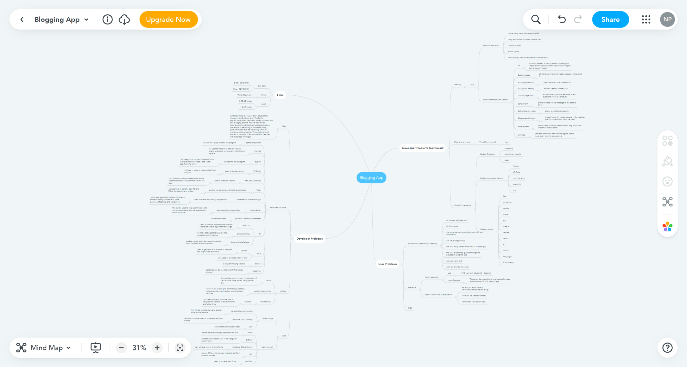

# Existing Solutions

|  |  |
| --- | --- |
| EXAMPLE | ANNOTATIONS |
|  | Has a cover image of the user, allowing them to provide addition visual feedback.  Displays the name of the user is large font to improve the accessibly of the page.  The profile image of the user is displayed at the top. It is sat in the middle of the two divs.  The amount of likes and followers that the user has is displayed under their name.  The layout of this page is neat, with all navigation being easy to find and all sections being placed logically. This improves the learnability of the page.  An information card about the user is displayed to inform visitors of who they are, where to find them and how to contact them.  All the user’s posts are neatly organised in a column, with images being displayed under the text.  The post do not allow for titles, only body text  The posts allow for more than one image to be displayed. This allows for more information to be provided.  Posts have a ‘see more’ button if there is a lot of text. This makes it so posts do not take up too much space.  The webpage is responsive and can be displayed on all screen sizes. This improves the utility and accessibility of the app (SDC14).  The webpage has multiple sections about the user, such as, ‘about’, ‘posts’, ‘photos’ and ‘videos’. This makes it so everything is not cramped into one page.  The page allows for videos to be uploaded.  Users can like or comment on posts (SDC15)(SDC10).  Comments are nested so that visitors can reply to other comments (SDC10). |

# Project Timeline

# Develop

## Wireframes

|  |  |  |
| --- | --- | --- |
| WIREFRAME | | ANNOTATIONS |
|  | The navbar is always displayed at the top of the page to improve the learnability of the site.  The image of the blog will be displayed as the background at the top of the page and will overflow under the navbar.  The title, description, author, and like/dislike count will be displayed at the top of the page.  There is a ‘read more’ button to improve the utility of the page.  The tags and categories of the blog will be displayed about the title (SDC21).  The title, author and description will be displayed again above the blog content.  A follow button will be displayed next to the authors username (SDC17).  The usernames will be links to their account page.  The layout of the site is neat and modern to improve the utility and learnability of the site (SDC12).  Text will use appropriate contrast to improve accessibility.  A social section will be displayed under the content where the authors username will be displayed once more. Users can also follow/unfollow the author here as well as like/dislike the blog (SDC17) (SDC15).  A comments section will be displayed under the social section.  A user must be logged in to comment, reply, edit comment, like. Dislike and follow/unfollow. They will be redirected to login if they try to use these features.  If the author views their own blog, an ‘edit blog’ button will be displayed instead of a follow button (PC10).  Comments will be nested so users can reply to other comments (SDC10).  Users can edit or reply to their own comments (SDC10).  User’s can also like/dislike comments | |

|  |  |
| --- | --- |
|  | Featured blogs will be displayed at the top of the page (SDC23). These blogs are gathered from the amount of likes – dislikes. The blogs title, author, date, and categories/tags are displayed. Users can read more by pressing the ‘read more’ button. The featured blogs are displayed on a slideshow animation to maximise the number of blogs that can be displayed, and to engage the user (SDC13).  Blogs can be filtered using the filter section where blogs can be searched (SDC22), or filtered by their tags or categories.  Active filters applied will be displayed at the top of the blogs section, to inform the user about the active filters. This is to improve learnability.  The responsiveness of this page will be adjusted to all screen sizes to improve accessibility (SDC14)  Each blog will be displayed on a card, where their most relevant category of tag (gathered using AI), will be displayed at the top. Below that is the blog title. The blogs author and date will be displayed on the card. Finally, the blogs description will also be displayed.  To ensure the page does not go on forever, pagination will be used to ensure only 6 blogs are displayed at a time.  Users can navigate the pages by using the page navbar at the bottom. |
|  | The title of the page is displayed at the top in a large font to improve learnability and accessibility.  Both the edit and create page use the same layout. However, the edit page has the blogs values inserted into the input fields.  This form uses multiple fields to minimise the amount of vertical space needed. Is allow allows for validation to be done at each step, using JavaScript (SDC6).  The steps are displayed at the top and will indicate what step the user is currently on. This was to improve learnability.  Users can go to previous steps if needed to improve utility.  The form inputs are displayed with labels to improve learnability.  AI is used to provide suggestions, based on their current input, as the user types (SDC19).  An AI spell check is used once the form is submitted to fix and mistakes (SDC9).  Users can upload their own images or use AI images (SDC16).  These images are created based on the description of the blog.  Users can also save as drafts or achieve the blogs (SDC24) |
|  | The client’s logo is displayed on each step of the signup form to improve learnability.  The signup form uses three steps to validate each section before continuing. Furthermore, it allows for the email from the first section to be used to send the code for the second section (SDC5).  The head of each section informs the user of what to do to improve learnability.  The form is responsive and can fit any screen size to improve accessibility.  The user can go back if they put in the wrong information.  Error messages are clearly displayed and use a appropriate contrast to improve accessibility.  The steps of the form will be displayed at the bottom to inform the user of what step they are on. This is to improve learn ability.  Users must accept the terms and conditions before signing up.  Passwords are hidden to improve the user’s privacy and security.  Passwords will also be hashed upon account creation (SDCpc8) |

## Data - Variable Table

|  |  |
| --- | --- |
| Variable Name | Variable Description |
| blogs | Stores all blogs in a pagination list |
| db | The initialised database object for SQLAlchemy |
| app | The initialised variable for the flask app |
| Current_user | Holds the data for the current user |
| Related_comments | Stores nested comments for the blog that are related to other comments |
| User.admin | Is a Boolean for whether the user is an admin |
| form | The initialised object of the form |
| error | Stores the error for any forms |
| Main, signup, account, blog, … | Stores the initialised object for the blueprint of the flask app |
| title | Stores the title for the webpage |
| matrix | Is a 2D list (matrix) of distances between two strings |
| suggestion | A suggested word based on the incorrect spelling of a word |

## Dataflow Diagrams

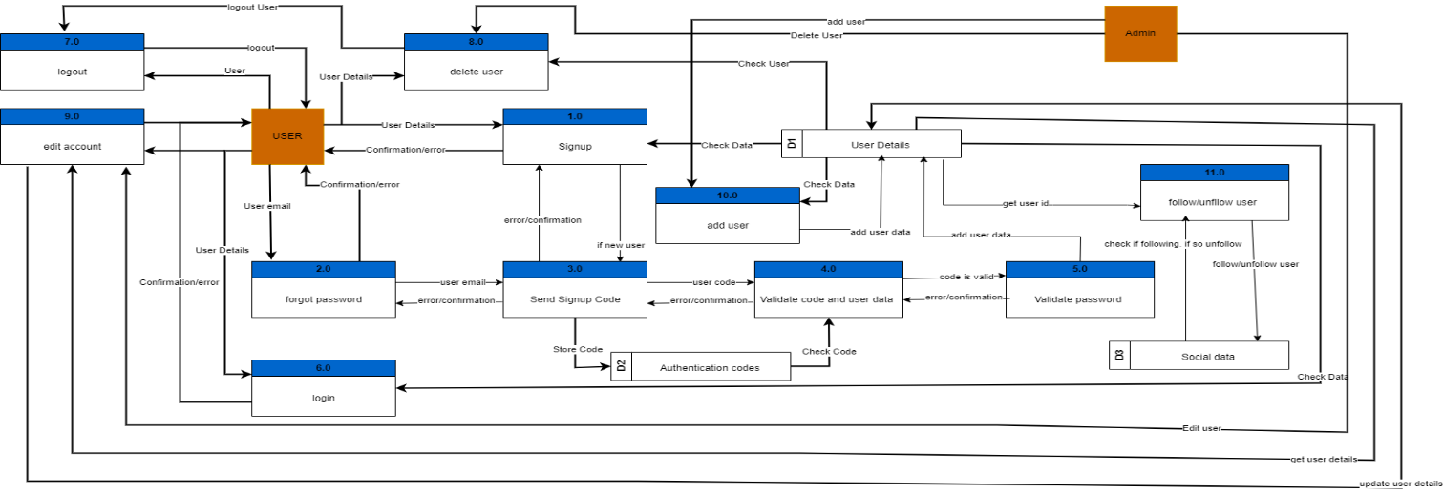

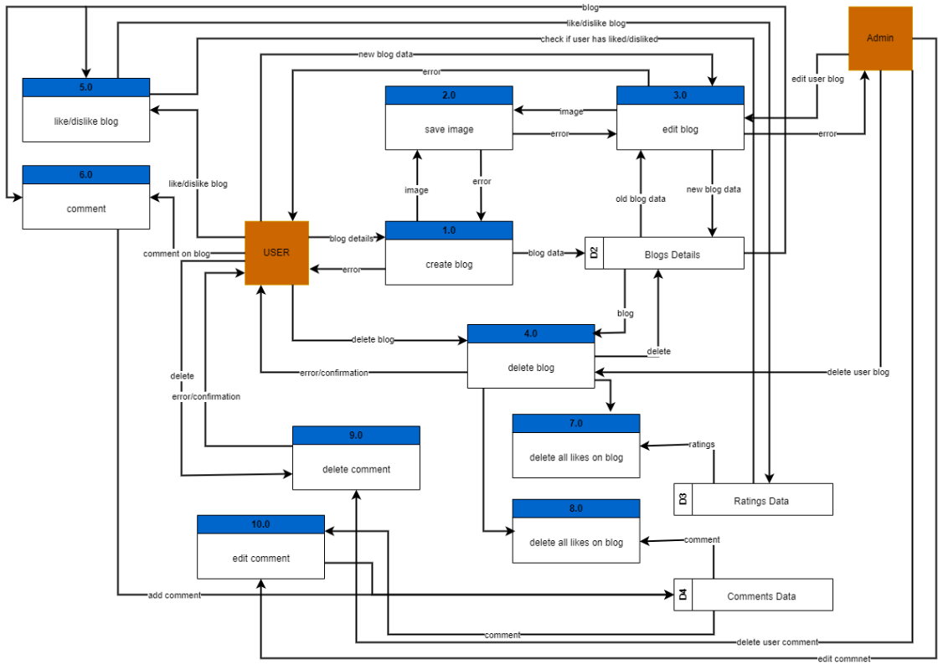

## Entity Relation Diagram

## Site Map

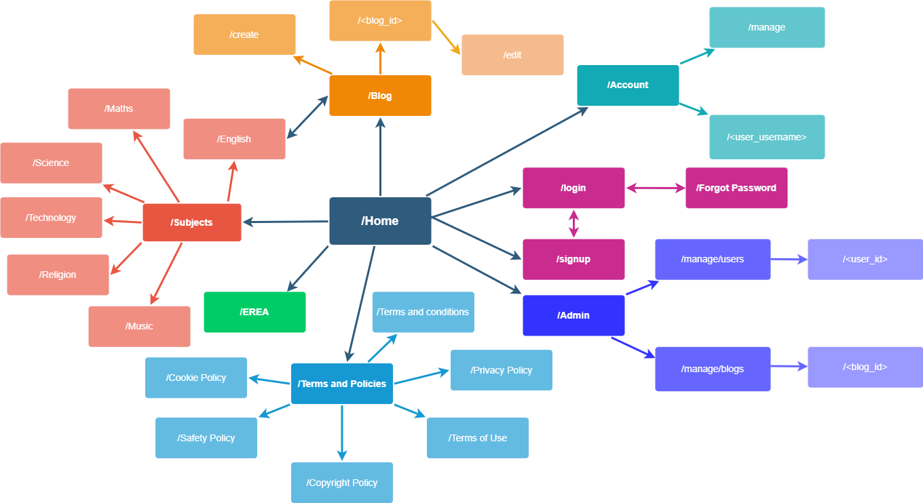

## Data Dictionaries

### User Table

|  |  |  |  |  |  |
| --- | --- | --- | --- | --- | --- |
| Field Name | Data Type | Data Format | Field Size | Description | Example |
| id | integer | Primary Key | 32 digits | Is the primary key for the user table | 3 |
| first_name | string |  | 100 chars | The user’s first name | Nathan |
| last_name | string |  | 100 chars | The user’s last name | Perrier |
| email | string | Email address | 100 chars | Is the primary identification of the user | 056671@atc.qld.edu.au |
| username | string |  | 50 chars | Is the users display name | Nathanperrier23 |
| address_id | integer | Foreign Key | 32 digits | The forging key for the address table | 5 |
| bio_id | integer | Foreign Key | 32 digits | The foreign key for the bio table | 2 |
| phone_number | string |  | 20 chars | The user’s phone number | 0412345678 |
| avatar | string | directory | 300 chars | The directory of the user’s avatar | ../d23g4f8asd3.png |
| admin | Boolean |  | 1 digit | Stores where the user is an admin | 1 (True) |

### Blog Table

|  |  |  |  |  |  |
| --- | --- | --- | --- | --- | --- |
| Field Name | Data Type | Data Format | Field Size | Description | Example |
| id | integer | Primary Key | 32 digits | Is the primary key for the user table | 7 |
| User_id | integer | Foreign Key | 32 digits | The forging key for the user table | 1 |
| title | string |  | 100 chars | The title of the blog | A blog about blogs |
| description | string |  | 150 chars | The blog’s description | Blogs are the panicle of… |
| content | datetime | DateTime | date | The date of when the blog was posted | 12/12/23 |
| image | string | directory | 300 chars | The directory of the blog’s image | ../d23g4f8asd3.png |
| status | string |  | 20 chars | The status of the blog | “active” |

## Pseudocode

|  |
| --- |
| Pseudocode |
| BEGIN// Define the Levenshtein distance functionFUNCTION levenshtein_distance(self, s1, s2):// Create a matrix to store distancesSET matrix = create a 2D list of zeros with dimensions (len(s1) + 1) x (len(s2) + 1)// Initialize the first row and columnFOR i FROM 0 TO len(s1):SET matrix[i][0] = iFOR j FROM 0 TO len(s2):SET matrix[0][j] = j// Fill in the matrix using dynamic programmingFOR i FROM 1 TO len(s1):FOR j FROM 1 TO len(s2):// Calculate the costSET cost = 0 IF s1[i - 1] IS EQUAL TO s2[j - 1] ELSE 1// Update the current cell with the minimum of adjacent cells + costSET matrix[i][j] = MIN(matrix[i - 1][j] + 1, matrix[i][j - 1] + 1, matrix[i - 1][j - 1] + cost)// Initialize pointers to the bottom-right of the matrixSET i, j = LENGTH(s1), LENGTH(s2)// Iterate over the matrix to find the edit operationsWHILE i IS MORE THAN 0 OR j IS MORE THAN 0:IF i IS MORE THAN 0 AND j IS MORE THAN 0 AND s1[i - 1] IS EQUAL TO s2[j - 1]:// Characters are the same, move diagonallySET i = i - 1SET j = j - 1ELSE IF i IS MORE THAN 0 AND matrix[i][j] IS EQUAL TO matrix[i - 1][j] + 1:// Move upSET i = i - 1ELSE IF j IS MORE THAN 0 AND matrix[i][j] IS EQUAL TO matrix[i][j - 1] + 1:// Move leftSET j = j - 1ELSE:// Move diagonallySET i = I - 1SET j = j - 1// Return the shortest distance (bottom-right cell of the matrix)RETURN matrix[LENGTH(s1)][LENGTH(s2)]END |
| BEGIN// Define the class method to get featured blogs @classmethod FUNCTION get_featured_blogs(cls, db):// Get all ratings from the databaseSET ratings = call Rating().get_all(db)// Create dictionaries to store the total likes and dislikes for each blogSET blog_likes = {}SETblog_dislikes = {}// Calculate total likes and dislikes for each blogFOR EACH rating IN ratings:IF rating.blog_id NOT IN blog_likes:SET blog_likes[rating.blog_id] = 0IF rating.blog_id NOT IN blog_dislikes:SET blog_dislikes[rating.blog_id] = 0IF rating.rating:SET blog_likes[rating.blog_id] += 1ELSE:SET blog_dislikes[rating.blog_id] += 1// Calculate the blog ratings based on likes and dislikes for each blogFOR EACH rating IN ratings:SET total_likes = blog_likes[rating.blog_id]SET total_dislikes = blog_dislikes[rating.blog_id]// Calculate the rating using the calculate_blog_rating methodSET rating.v = call Rating().calculate_blog_rating(total_likes, total_dislikes)// Sort the ratings in descending orderSET sorted_ratings = sort ratings by key=lambda r: r.v descending// Get the top 5 blog ids with the highest ratingsSET top_blog_ids = [r.blog_id for r in sorted_ratings]SET top_blog_ids = top_blog_ids[:5]// Get the top 5 blogs with the highest ratingsSET top_blogs = []FOR EACH blog_id IN top_blog_ids:top_blogs.append(call Blog().get_by_id(db, blog_id))RETURN top_blogs// Define the method to calculate blog ratings @classmethod FUNCTION calculate_blog_rating(self, likes, dislikes):// Calculate the ratio of likes to total votes (likes + dislikes)SET total_votes = likes + dislikes// Calculate the activity factorSET activity_factor = 1 + min(1, total_votes / 50)// Calculate the ratio and map it to the range [0, 2π]SET ratio = (0 IF total_votes == 0 OR likes == 0 ELSE likes / total_votes)SET x = 2 * math.pi * ratio// Calculate the rating using the given functionSET rating = ((2.5 * math.cos(x) + 2.5) IF x > 0 ELSE 0) * activity_factor// Round the rating to a maximum of 5 with a minimum of 0RETURN round(min(5, max(0, rating)), 2)END |
| BEGIN// Define a class method to create a new blog@classmethodFUNCTION create_blog(cls, db, user_id, title, description, content, image=None):TRY:// Check if an image is provided; if not, generate one using AIIF image IS None:SET image = ImageGeneration().get_ai_image(description)ELSE:SET image = cls.save_image(image, description)// Create a new blog object with the provided dataSET blog = create a new instance of cls with user_id, title, description, content, and image// Add the blog to the database session and commit changesdb.session.add(blog)db.session.commit()// Return success status, an empty error message, and the ID of the created blogRETURN True, '', blog.idEXCEPT Exception AS e:// Handle exceptions and return failure status along with the error message and an empty IDRETURN False, str(e), ''// Define a class method to edit an existing blog@classmethodFUNCTION edit_blog(cls, db, id, title, description, content, image):TRY:// Retrieve the blog by its IDSET blog = cls.get_by_id(db, id)// Update the blog's attributes with the provided dataSET blog.title = titleSET blog.description = descriptionSET blog.content = contentSET blog.image = image// Commit the changes to the databasedb.session.commit()// Return success status and an empty error messageRETURN True, ''EXCEPT Exception AS e:// Handle exceptions and return failure status along with the error messageRETURN False, str(e)// Define a class method to retrieve a blog by its ID@classmethodFUNCTION get_by_id(cls, db, id):// Query the database to find the blog with the specified IDRETURN db.session.query(cls).filter_by(id=id).first()END |
| BEGIN  // Import necessary libraries and modules  FROM flask IMPORT Flask, render template, request, jsonify  FROM flask_login IMPORT login_required, current_user  FROM your_app.models IMPORT Blog  // Define a Flask Blueprint for the 'blog' module  SET blog = create a Flask Blueprint for 'blog' with __name__ as 'blog'  // Define the route to create a blog page  @blog.route('/blog/create', methods=['GET', 'POST'])  @login_required  FUNCTION create_blog_page():  // Render the 'create.html' template with title and user information  RETURN render_template('blogs/create.html', title=TITLE, user=current_user)  // Define the route to post a new blog  @blog.route('/blog/create/post', methods=['POST'])  @login_required  FUNCTION post_blog():  TRY:  // Try to get an image from the request  SET image = get the 'image' file from request  EXCEPT:  // If no image is provided, set it to None  SET image = None    // Create a new blog using the Blog model  SET valid, error, blog_id = Blog().create_blog(db, current_user.id, request.form.get('title'), request.form.get('description'), request.form.get('content'), image)    // Return a JSON response with success status, error message, and blog ID  RETURN jsonify(success=valid, error=error, id=blog_id)  // Define the route to edit a blog page  @blog.route('/blog/<int:blog_id>/edit', methods=['GET', 'POST'])  @login_required  FUNCTION edit_blog_page(blog_id):  // Get the blog by its ID using the Blog model  SET blog = Blog.get_by_id(db, blog_id)    // Render the 'edit.html' template with title, user, and blog information  RETURN render_template('blogs/edit.html', title=TITLE, user=current_user, blog=blog)  // Define the route to post edited blog content  @blog.route('/blog/<int:blog_id>/edit/post', methods=['POST'])  @login_required  FUNCTION post_blog_edit(blog_id):  TRY:  // Try to get an image from the request  SET image = Blog().save_image(request.files['image'], request.form.get('description')) IF request.form.get('image') IS None ELSE request.form.get('image')  EXCEPT:  SET image = None    // Edit the existing blog using the Blog model  SET valid, error = Blog().edit_blog(db, blog_id, request.form.get('title'), request.form.get('description'), request.form.get('content'), image)    // Return a JSON response with success status and error message  RETURN jsonify(success=valid, error=error)  // Define the route to delete a blog  @blog.route('/blog/<int:blog_id>/delete', methods=['POST'])  @login_required  FUNCTION delete_blog(blog_id):  // Delete the blog using the Blog model  SET success, error = Blog().delete_blog(db, blog_id)    // Return success status and error message  RETURN success, error |
| @classmethodFUNCTION check_email(cls, email):"""Check if the email is in the database."""result = db.session.query(User).filter_by(email=email).first()RETURN result@classmethodFUNCTION is_name_valid(cls, name):"""Check if the name is valid"""valid_chars = "ABCDEFGHIJKLMNOPQRSTUVWXYZabcdefghijklmnopqrstuvwxyz-"FOR char IN name:IF char NOT IN valid_chars:RETURN FalseRETURN True@staticmethodFUNCTION generate_code(length=6):"""Generate a random numerical reset code of the given length."""code = ''FOR _ IN RANGE(length):random_char = random.choice(string.ascii_letters + string.digits)code += random_charRETURN code@staticmethodFUNCTION send_reset_code(first_name, email, code):"""Send the reset code to the user's email."""TRY:send_email('contact.webgenieai@gmail.com', email, create_email(first_name, email, 'Verification Code', code))EXCEPT Exception AS e:PRINT(e)@classmethodFUNCTION store_reset_code(cls, email, code, expiration_duration=1800): # 30 mins"""Store the reset code in the database with an expiration time."""expiration_time = datetime.utcnow() + timedelta(seconds=expiration_duration)reset_entry = SignupCode(email=email, reset_code=generate_password_hash(code), expiration_time=expiration_time, creation_time=datetime.utcnow())db.session.add(reset_entry)db.session.commit()@classmethodFUNCTION create_and_send_reset_code(cls, first_name, last_name, email):"""Generate, send, and store the reset code."""email_check = cls.check_email(email)IF email_check IS None:IF cls.is_name_valid(first_name) AND cls.is_name_valid(last_name): // check if the user’s name validIF cls.check_email_format(email): //check if email is correct formatIF cls.check_active_code(email): // check if code is active// if there is no active codecode = cls.generate_code()cls.send_reset_code(first_name, email, code)cls.store_reset_code(email, code)RETURN True, NoneRETURN True, None // has active code (continue)RETURN False, 'Invalid Email Format'RETURN False, 'Invalid Name(s)'RETURN False, "Email Already Registered"@classmethodFUNCTION check_email_format(cls, email):// checks if email has an @ and a .TRY:username, domain = email.split('@')domain, tld = domain.rsplit('.', 1)RETURN TrueEXCEPT ValueError:RETURN False@classmethodFUNCTION check_active_code(cls, email):// checks if there is a code that’s experation time has not been reachedactive_code_check = db.session.query(cls).filter_by(email=email).filter(SignupCode.expiration_time > datetime.utcnow()).first()IF active_code_check:RETURN FalseRETURN True@classmethodFUNCTION check_code(cls, user_code, code):// unhashed code and checks if the inputted code is the sameRETURN check_password_hash(user_code, code)@classmethodFUNCTION check_reset_code(cls, email, input_code):// checks if code is validreset_entry = db.session.query(cls).filter_by(email=email).order_by(SignupCode.creation_time.desc()).first()IF NOT reset_entry:RETURN False, "No reset code found for the user"IF cls.check_code(reset_entry.reset_code, input_code) IS False:RETURN False, "Invalid reset code"current_time = datetime.utcnow()IF current_time > reset_entry.expiration_time:RETURN False, "Reset code has expired"RETURN True, None |

## Generate

## User Interfaces

|  |  |
| --- | --- |
| Interface | Annotations |
|  | Good use of white-space to ensure the webpage is not “crowded” with information or data  Has a slideshow to maximise the number of featured blogs that can be displayed  Blog images act as a background image for the slideshow  Readers can press on “read more” to be redirtected to blog page. This is to increase the utility  The featured blogs are gathered from the number of likes a blog has  The recommended blogs are also displayed on a slideshow. Users can click on them to be read more  An animation occurs when hovered on the recommended section  There is a filter section where users could filter or search blogs, however this feature was not added.  The layout and styling is neat, modern and not overwhelming. Followiungs the clients scheme  A max of 6 blogs is displayed at a time. Users can use the navbar at the bottom of the section to change the page  The responsiveness of this page will be adjusted to all screen sizes to improve accessibility (SDC14)  All buttons and navbars are located in logical locations to improve the learnability of the site  The contrst of text and colours is reasonable to improve accessability  Users can follow/unfollow user’s whose blogs are displayed on the featured section. If the current user is an admin then it will be a edit button. |
|  | User’s passwords are not displayed to increase the sites safety  All important information is displayed for each user.  The page can only be accessed by admins. If theuser is not an admin the will be redirected to a 401 (unauthorised) error page.  Admins can add a new user without needed to receive a authentication code  Admins can search users by id, username, email or name. based on the search users willl be sorted in terms of similarity.  Admins can veiw, edit or delete users. If the user is an admin then they can only veiw the account. Also admins can only veiw or edit their own account, they cannot delete their own account.  The table uses pagination to minise the amount of verticle space needed. Only 10 users are displayed each page.  The table fields are evenly space. Furthermore the table is responsive to improve accessbility.  The layout of the table is simple to improve leanrability. Furthermore, the symbols used for the buttons are intuative  The profile picture of each user is displayed. |
|  | This design was heavily inspired by the existing solution analysed. As can be see the interface takes multiple elements from the analysed design. This was done to improve learnability as the design and layout is popular.  Both the your account page and user account page use a similar layout  The user’s profile picture is displayed, with a edit account button bellow.  The user’s name and username are displayed at the top of the page to make it easy to see.  the number of blogs, follower and following is displayed to inform the user  the user’s bio is displayed on this page. The bio can be updated in the manage account page  the user’s blogs are also displayed here, that visitors to their page will also see.  The blogs have filter ovtions in the top navbar, however this was not fully implimented.  While only 4 blogs per page are displayed, users can cycle through their blogs usning the bottom page navbar.  This page is fully respoonsive to improve accessiblity.  Furhtermore, users casn use the footer for additional navigation. |

## Code

|  |
| --- |
| Code |
| def levenshtein_distance(self, s1, s2):          # Creates a matrix to store distances          matrix = [[0 for _ in range(len(s2) + 1)] for _ in range(len(s1) + 1)]  # creates a 2D list (matrix) of zeros with dimensions (len(s1) + 1) x (len(s2) + 1)            # Initialize the first row and column          for i in range(len(s1) + 1):              matrix[i][0] = i # fill in the first column with range(len(s1) + 1)          for j in range(len(s2) + 1):              matrix[0][j] = j # fill in the first row with range(len(s2) + 1)            # Fill in the matrix using dynamic programming          for i in range(1, len(s1) + 1):              for j in range(1, len(s2) + 1):                  cost = 0 if s1[i - 1] == s2[j - 1] else 1 # cost is 0 if the characters are the same, 1 otherwise                  matrix[i][j] = min(matrix[i - 1][j] + 1, matrix[i][j - 1] + 1, matrix[i - 1][j - 1] + cost) # fill in the current cell with the minimum of the three adjacent cells + cost            i, j = len(s1), len(s2)          while i > 0 or j > 0: #itierates over the matrix until it reaches the top left corner              if i > 0 and j > 0 and s1[i - 1] == s2[j - 1]: #if the characters are the same, move diagonally                  i -= 1  #move diagonally                  j -= 1              elif i > 0 and matrix[i][j] == matrix[i - 1][j] + 1: #if the cost of the current cell is equal to the cost of the cell above + 1, move up                  i -= 1 #move up              elif j > 0 and matrix[i][j] == matrix[i][j - 1] + 1: #if the cost of the current cell is equal to the cost of the cell to the left + 1, move left                  j -= 1 #move left              else:                  i -= 1 #move diagonally                  j -= 1            return matrix[len(s1)][len(s2)] |
| # From: backend/hosting/__init__.py  from backend.config import *  from backend.__init__ import *  def create_app():      # Initialize app      app = Flask(__name__, template_folder='../../frontend/templates/', static_folder='../../frontend/static/')        # Configure app      app.config['SQLALCHEMY_DATABASE_URI'] = 'sqlite:///site.db'      app.config['SECRET_KEY'] = random.randbytes(32)      app.config['BLOG_UPLOAD_FOLDER'] = 'frontend/static/images/user-images/blogs/'      app.config['AVATAR_UPLOAD_FOLDER'] = 'frontend/static/images/user-images/avatars/'      app.config['AI_UPLOAD_FOLDER'] = 'frontend/static/images/ai-images/blogs/'        # Initialize extensions      login_manager.init_app(app)      # Register blueprints      app.register_blueprint(main)      app.register_blueprint(sign_up)      app.register_blueprint(terms)      app.register_blueprint(blog)      app.register_blueprint(subject)      app.register_blueprint(forgot)      app.register_blueprint(account)      app.register_blueprint(admin)      app.register_blueprint(tracking)        # Register error handlers      register_error_handlers(app)        # Initialize database      db.init_app(app)      # Create database tables      with app.app_context():          db.create_all()      return app |
| def get_ai_image(self, description):          # get the response from the OpenAI API          response = openai.Image.create(              prompt="Generate a digital image for a blog post with the following description: " + description,              n=1,              size="1024x1024",          )          # save the image to the server          name = self.save_image(response['data'][0]['url'])          return FILE_PATH + name  def save_image(self, url, file_path=None):          # get image unique directory          directory = self.check_dir((FILE_PATH_AVATAR + self.generate_name() + '.png'), file_path=True) if file_path else self.check_dir((FILE_PATH + self.generate_name() + '.png'))          # get url data          img_data = requests.get(url).content          # save image to directory          with open(directory, 'wb') as handler:              handler.write(img_data)          if file_path:              return directory.split(FILE_PATH_AVATAR)[1]          return directory.split(FILE_PATH)[1]        def generate_name(self, length=50):          # generate a random name for the image          return ''.join(random.choice(string.ascii_letters + string.digits) for _ in range(length))        def check_dir(self, directory, file_path=None):          # check if the directory exists          if os.path.exists(directory):              return self.check_dir((FILE_PATH + self.generate_name() + '.png')) if file_path == None else self.check_dir((FILE_PATH_AVATAR + self.generate_name() + '.png'), file_path=True)          return directory |
| @sign_up.route('/signup', methods=['GET', 'POST'])  def signup_page(error=''):      return render_template('signup.html', title=TITLE, error=error)  @sign_up.route('/signup/validate_email', methods=['POST'])   #! issue  def signup_validate_email():      valid, error = SignupCode.create_and_send_reset_code(request.form.get('first_name'), request.form.get('last_name'), request.form.get('email'))      return jsonify(success=valid, error=error)  @sign_up.route('/signup/validate_code', methods=['POST'])  def signup_validate_code():      valid, error = SignupCode.check_reset_code(request.form.get('email'), request.form.get('reset_code'))      return jsonify(success=valid, error=error)  @sign_up.route('/signup/validate_password', methods=['POST'])  def signup_validate_password():      valid, error = User.signup(request.form.get('first_name'),request.form.get('last_name'), request.form.get('email'), request.form.get('new_password'))      return jsonify(success=valid, error=error) |
| from backend.config import *  from backend.tests.db import db  class TestFlaskApp(unittest.TestCase):        def setUp(self):          # initialize the flask app          self.app = Flask(__name__)          self.app.config['TESTING'] = True          self.client = self.app.test_client()        def test_index(self):          # test the index page          response = self.client.get("/")          self.assertEqual(response.status_code, 200)          self.assertIn(b"Welcome to the Tracking App", response.data)      def test_404(self):          # test the 404 page          response = self.client.get('/404')          self.assertEqual(response.status_code, 404)          self.assertIn(b"Page not found", response.data)        def test_500(self):          # test the 500 page          response = self.client.get('/500')          self.assertEqual(response.status_code, 500)          self.assertIn(b"Internal server error", response.data)        def test_login(self):          # test the login page          response = self.client.get('/login')          self.assertEqual(response.status_code, 200)          self.assertIn(b"Login", response.data)        def test_signup(self):          # test the signup page          response = self.client.get('/signup')          self.assertEqual(response.status_code, 200)          self.assertIn(b"Register", response.data) |

# Evaluation

## Testing

|  |  |  |  |  |
| --- | --- | --- | --- | --- |
| TEST | EXPECTED OUTCOME | ACTUAL OUTCOME | RECOMMENDATIONS | ACHIEVED |
| A Test to use dynamic ids for comment inputs | JavaScript would retrieve the input data using the dynamic ids | The data would not be retrieved | Check if there are ids with the same name | Yes, had double ups of id names so was not finding correct id |
| A test to use JavaScript to post user data | JavaScript would post data to python route | Would raise an error about blog_id being missing | Pass through blog_id in route | Yes, included blog_id in route using jinja |
| A test to use pagination | Would allow for all users to be displayed over many pages | Arrows would not redirect to correct page | Make sure the correct page number is being passed through | Yes, was not passing through correct page number |
| A test to store user data | Would store the new user | User would be deleted on restart | Make sure data is being committed | Yes, added db.session.commit() |

## User Testing

|  |  |
| --- | --- |
| Type of Test | Completion Status |
| Can the user open the website? | [**✓]** |
| Can the user close the website? | [**✓]** |
| Can the user navigate the website? | [**✓]** |
| Can the user login? | [**✓]** |
| Can the user logout? | [**✓]** |
| Can a user get admin permissions (if applicable)? | [**✓]** |
| Can the user edit/delete their data? | [**✓]** |
| Can the admin edit/delete user and blog data? | [**✓]** |
| Can the user create a new account? | [**✓]** |
| Can the user create/edit/delete a blog? | [**✓]** |
| Can the user comment on blogs? | [**✓]** |
| Can the user like/dislike blogs? | [**✓]** |
| Can the user follow/unfollow other users? | [**✓]** |

## User Feedback

|  |  |
| --- | --- |
| Name | Feedback |
| Jasmine | “Home screen is welcoming. Great inclusion of footage of the school and text/font is fitting the professional aesthetic of the website. Contact us section is fully functional and easy to use. Some buttons on homepage don’t do anything. Well-presented pages that have a lot of variety. Good design in the layout of the blog posts. Search bar within the blog page is not yet functional. Creating a blog was an easy process, steps were clearly illustrated, and all aspects were functional. I like the admin page and the fact that I can search users” |
| Aditya | “When testing the website, I was pleasantly surprised of how well the html and CSS was designed. The login system was top notch and could be compared with other competitors. The only issues I faced with the website were the slow animations. Alse Emails do not send when on school Wi-Fi” |

## Criteria

|  |  |  |  |  |  |  |
| --- | --- | --- | --- | --- | --- | --- |
| PRESCRIBED CRITERIA | | |  | SELF-DETERMINED CRITERIA | |  |
| PC1 | Develop a website with many pages and features | | [**✓]** | **SDC1** | Using objects to code in a modular way | [**✓]** |
| PC2 | Allow multiple users to use the website and have the ability for new users to be added | | [**✓]** | **SDC2** | Using lists, arrays, and dictionaries to store data | [**✓]** |
| PC3 | Use databases for data storage | | [**✓]** | **SDC3** | Allow users to upload and customise their profile picture | [**✓]** |
| PC4 | Create a folio that outlines the user interface and coded components of the solution | | [**✓]** | **SDC4** | Use authentication codes to confirm user authenticity | [**✓]** |
| PC5 | Have blog functionality that all users, can use, view and access | | [**✓]** | **SDC5** | Send emails to users to send necessary information | [**✓]** |
| PC6 | Generate a user/visual interface | | [**✓]** | **SDC6** | Use JS for data handling and design elements | [**✓]** |
| PC7 | Incorporate the use of the client’s signature colours or logo | | [**✓]** | **SDC7** | Allow the users to reset their passwords if forgotten | [**✓]** |
| PC8 | Integrate security features such as hashing and encryption | | [**✓]** | **SDC8** | Develop and use the Lowenstein distance algorithm | [**✓]** |
| PC9 | Users must be able to edit or delete their information | | [**✓]** | **SDC9** | Integrate a spell check in the blog functionality | [**x]** |
| PC10 | Have admin functionality that is given to the client’s staff. They should be able to edit, delete and add user and blog data. | | [**✓]** | **SDC10** | Have nested comments for blog that users can edit and delete | [**✓]** |
| PC11 | Allow for users to login, signup and logout | | [**✓]** | **SDC11** | Use SQLAlchemy and a multi-file architecture for the code design | [**✓]** |
| CRITERIA | | **REASON** | | **SDC12** | Use CSS to style the website to adhere closely with the client’s style | [**✓]** |
| SDC9 | | This feature was not added due to a lack of time and insufficient training data | | **SDC13** | Use animations on the website to engage the user | [**✓]** |
| SDC18 | | This feature was not added as there was not enough time | | **SDC14** | Prioritise website responsiveness to improve accessibility | [**✓]** |
| SDC19 | | While the code was developed, the training data was not sufficient | | **SDC15** | Have a like-dislike system for blogs | [**✓]** |
| SDC20 | | There was not enough time to implement this as the frontend part of it required a bit of time | | **SDC16** | Use AI to generate blog images if the user has no image to upload | [**✓]** |
| SDC21 | | This feature was not added as it was mainly needed for the AI features that were not added | | **SDC17** | Have a social system where users can follow/unfollow other users | [**✓]** |
| SDC22 | | This was not added as the algorithm to do this is quite complex | | **SDC18** | Develop a notification system where user’s will be notified when they are followed or a user, they are following uploads a blog | [**x]** |
| SDC24 | | As this featured required for the database and its process to be reconfigured, it became too time consuming | | **SDC19** | Have an AI to suggest words or sentences as the user is typing | [**/]** |
| SDC31 | | This feature required tracking to be added first, which is why it was not implemented | | **SDC20** | Have an AI to generate blog titles or descriptions | [**x]** |
| SDC32 | | This feature required to much time to add | | **SDC21** | Allow for users to add tags or categories to their blogs to allow to inform readers and add context. This will also be used for the search feature | [**x]** |
|  | | | | **SDC22** | Allow users to search for blogs or users | [**x]** |
| **SDC23** | Have a featured blog section were the blogs with the most likes or engagement (number of comments) will appear | [**✓]** |
| **SDC24** | Allow users to achieve their blog posts or save as a draft when creating one | [**x]** |
| **SDC25** | Use drone footage of the Client’s campus to engage users when they click on the website | [**✓]** |
| **SDC26** | Have terms and policies regarding the use of the website. Make users agree to these terms before signing up | [**✓]** |
| **SDC27** | Have multiple pages regarding information about the client such as subjects or their relation to EREA | [**✓]** |
| **SDC28** | Have a contact form where users can ask questions | [**✓]** |
| **SDC29** | Have a newsletter where users can sign up and receive newsletters | [**✓]** |
| **SDC30** | Have unit tests for various programming elements | [**✓]** |
| **SDC31** | Have activity logs that the user and admin can view | [**x]** |
| **SDC32** | Have tracking functionality that identifies the user’s or a device’s likes in terms of the blogs they view. Use this data to recommend blogs to the user. | [**x]** |
| **SDC33** | Have AI generated and default profile pictures gathered from API’s. | [**✓]** |
| **SDC34** | Allow admins to search for users based on their id, username, name or email | [**✓]** |

## **Impacts**

### Social

As this project is a social app, it introduces many social impacts that need to be considered. As the success criteria outlines many features that bring users together, such as following/followers (SDC17), likes/dislikes (SDC15), comments (SDC10), notifications (SDC18), and blogging (PC5). These features make the app allow communities to connect with one another. Furthermore, due to the inclusion of user’s being able to communicate with others through the comments and blogging system, users can plan or advertise social events. Finally, while users can voice their opinions, which may be harmful to other users. while this is addressed in the app’s terms and conditions (SDC28), the impact is still present.

### Personal

A personal impact due to the app’s development is the fact that users could get addicted to the app and its features. This means that users could prioritise the use of the app over other aspects of their life, such as going outside. Finally, as partially mentioned previously, users on the app could encounter harassment or bullying through the app’s communication system. This may lead to potential mental health issue that pose as a vast personal impact. Finally, through the use of AI it could pose as a personal threat of data security.

### Economical

Through the use of the app’s communication and blogging system, businesses or products could be advertised that would benefit the economy. Furthermore, with the possible expansion of this app, employees could be hired to aid with the development. This would introduce many new jobs in the local area. Furthermore, to compensate for the cost of employees and future politization, monetisation could be used to generate a sufficient income. The app could be monetised through, adds, subscriptions or an on-time-fee.

### Legal

As the app utilises AI in the aid of content creation, there is various legal impacts in its use. As AI could leak, or misuse user data its user has to be monitored. Furthermore, to cover the apps and client’s liability in the use of AI, the user upon signup must agree to the site’s terms and conditions (SDC28). Furthermore, the AI and the app’s users could spread misinformation, where legal action may be necessary. A major legal liability is the applications use in the conduction of illegal activities. Finally, legal action may be needed if a person or group is harmful to the app or its users.

## Usability recommendation

As usability was a key part of the design of the website there are little improvements to be made. Although after extensive user feedback it was determined that there are some features and buttons that are not function. As time was a major restriction in the app’s development, some pages and buttons found on the homepage and other various pages were not function and are purely decorative. Furthermore, as outlined in the success criteria there are multiple features that could not be completed. This resulted in many buttons, inputs and sections being incomplete in the blogging, user and account sections. Furthermore, it was identified that the emailing library used does not work when on a organisations Wi-Fi network. While the library could be swapped, a private network can be used to access the feature. Furthermore, it was identified that the clear but throughout inclusion of the clients’ colours, pictures and logos was commended. Additionally, users found all forms and navigation easy to use and follow. However, it was identified that the animations and main video were slow, this is mainly due to hardware limitations, but adjustments could be made. Overall, the usability feedback on the website was minimal with only the missing features being the main issue.

## Accessibility Checklist

|  |  |
| --- | --- |
| Accessibility | Achieved |
| Text is large enough to easily read | [**✓]** |
| User can exit or logout at anytime | [**✓]** |
| Do all buttons text boxes work | [**✓]** |
| Information is provided if the user would ever be unsure of what to do | [**✓]** |
| Information is provided is an error occurs | [**✓]** |
| Text colour contrast is reasonable | [**✓]** |
| Can a screen reader describe all images used | [**✓]** |
| Is audio available for users with hearing-impairment | [**✓]** |

# Additional Evaluation

## Risks Taken

During planning and development of this project it was identified that the scale was a major risk due to the limitation of time. As seen in the success criteria there are 34 self-determined criteria’s, this required for vast amounts of time and skill to be required. While not all of these self-determined criteria were successfully developed, over 27 were included. Furthermore, on top of this, 11 prescribed criteria were necessary, resulting in a total of 38 implemented features. Therefore, the scale of project caused around 20,000 lines of code, over 100,000 files and 7GB of storage to produce the final product. Thus, displaying the significant risk taken in implementing the success criteria.

Furthermore, there are certain features presented in the success criteria that introduced risk in the completion of the task. To add store the data for all the app processes, SQLAlchemy (SDC11) was used as it allows for query-less altering. Thus, to implement the database the code had to be structured to what was required. This meant that, as I was using Flask, Flask blueprints were needed. Flask blueprints allow for multiple hosting files to be used, this made it possible to use SQLAlchemy without any circular import errors. However, the implementation of these two features took a vast amount of time. Additionally, as the design of the website was an integral part of the project, a lot of time was dedicated to the creating, refining and implementing many of the webpages (SDC12). Furthermore, to excel the web design of the project, various animations we used to make the website more entertaining (SDC13). However, to include these animations, knowledge in the use of API’s, Plugin’s and JavaScript was needed. Further knowledge in JavaScript was needed in order to manage the form processes, this is because it was used primarily to retrieve data, process data and post data. Therefore, time was necessary in gaining the required skill to complete this.

As some features within the success criteria required extensive skill and complexity, it made implementing these features a vast risk due to the time required. To increase the safety and security of the app, code authentication was added to the signup and forgot password forms (SDC4). This was done to identify if the email entered is in fact a valid email. To add this feature, two addition database tables and multiple functions had to be added. Moreover, to increase the social aspects of the website, comments (SDC10), likes/dislikes (SDC15), follow/unfollow (SDC17) systems were added. These features, however, took a lot of time to add, making them a risk in the project’s development. In addition, various AI models were added to ease aspects in data create for the users. To implement these models, a lot of time had to be dedicated into research and development to ensure the best possible result. Furthermore, an increase in skill and knowledge in this field had to be gained. While not all models were successfully implemented, these features required immense amounts of time. Finally, while this was not stated in the success criteria due to length constraints, the use of pagination on the user, admin and blog pages were a risk due to the time take to learn how to incorporate it. However, while it did take time to add, it successfully displays users and blogs over multiple pages, to increase the overall design of the website.

While these are only some of the risks taken, it illustrates how due to the scale and complexity of this project, time became a major risk.

## What Was Learnt

When developing the project there were many things that had to be learnt. The most challenging and time-consuming concepts were related to the AI algorithms. When attempting to develop and implement the spell checker and autocomplete features, the Levenstein algorithm (SDC8) had to be used. The Levenstein algorithm is used to calculate the similarity or distance between two strings (GeekForGeeks (b), 2023). As this algorithm requires extensive knowledge in matrixes and dynamic programming. Dynamic programming is mainly an optimization over plain recursion and is known to be a complex concept in programming (GeekForGeeks (a), 2023). With the added default of including matrixes, it made this algorithm very difficult to implement, however, it was successfully added.

Another feature that had a steep learning curve was the inclusion of text-completion algorithms (SDC19). While a working prototype of this feature was created, it was deemed insufficient for what was required. Even though this feature was not added, to get a working prototype, many stages of research and development was necessary. From the user of libraries to the development of original AI large language models, it required a vast number of concepts to be learnt.

Finally, the last feature that required a lot of knowledge was the implementation of recommended and featured blogs (SDC32) (SDC23). For the recommended blogs feature, it was decided that user tracking was to be used to understand what blogs the user likes. Using this data blogs would be recommended using AI models. While a prototype of the AI model was developed, it was not satisfactory for what was needed. Furthermore, due to time constraints the tracking feature was not implemented into the final product. While this feature was not complete it did require a lot of knowledge about user tracking and AI algorithms. To gain this knowledge, research into infamous recommendations algorithms was done. Such algorithms were created by companies such as twitter or LinkedIn. Furthermore, for the featured blogs, research was conducted to find the best possible solution. Eventually, it was concluded that a trigonometric function was ideal. This is due to the fact that it can provide a rating between 0 and 5 based on the derivative $\frac{dy}{dx}$ of the linear function (y=mx+c). Therefore, the following function was developed:

$$rating.q= f\left(x\right)=\left\{\begin{aligned}0, &x=0 \\ \left(\frac{5}{2}\cos{(2π\left(x\right)+\frac{5}{2}}\right)×(1+min⁡(1, (total/50)), &x>0\end{aligned}\right.$$

*Where $x=\frac{dy}{dx}mx+c=\frac{likes}{total}$ and $total=likes+dislikes$*

Therefore, it can be shown that to develop these features, immense amounts of knowledge and research was necessary.

## Improvements and Limitations

As time was a major limiting factor in this project, it meant that several successes criteria’s were not implemented in the final product. Furthermore, additional implementations such as another admin page for user and blog tracking and various blogging features could have been added with additional time. These blogging features could have included the ability to have paragraph breaks, images in the content, intext-refencing and sub-headers. Another limitation was with the hardware. This is because, as the app used various animations and AI models it required a lot of computing power. This meant that the website may freeze due to the animations. Furthermore, it limited the use of AI as the use of original models were to much, thus, APIs had to be used instead.

## Real-world Applications

The real-world applications for this project are vast, this is because many modern websites utilise many of the features found in the final product. With the addition of authentication codes to the signup and forgot password systems, it mimics the industry standard for secure authorisation (Wallace, 2021). Furthermore, the inclusion of the blogging system provides insight into many systems and features used on most of the social media platforms. Finally, the use of AI is a popular addition of most modern websites, demonstrating its significant real-world application in future development.

# References

Aastha. (2021, July 20). Object-oriented programming concepts you must know to be a software developer. Medium. <https://medium.datadriveninvestor.com/object-oriented-programming-concepts-you-must-know-to-be-a-software-developer-5bf16956f8cc>

Applications of the 20 Most Popular Graph Algorithms. (2022, March 11). Applications of the 20 Most Popular Graph Algorithms. [https://memgraph.com/blog/graph-algorithms-applications#:~:text=A*%20is%20used%20in%20many,best%20route%20between%20two%20nodes](https://memgraph.com/blog/graph-algorithms-applications#:~:text=A*%20is%20used%20in%20many,best%20route%20between%20two%20nodes)

bwasti. (n.d.). jott - py3.11_vs_3.8. Jott - py3.11_vs_3.8. Retrieved February 20, 2023, from <https://jott.live/markdown/py3.11_vs_3.8#:~:text=It’s%20been%20making%20strides%20in,noticable%20speedup%20on%20my%20system.&text=Python%203.8%20took%2096.79%20seconds.&text=Python%203.11%20took%20only%2031.98,That’s%203x%20faster>!

GeekForGeeks (a). (2023, September 26). Dynamic Programming. GeeksforGeeks. https://www.geeksforgeeks.org/dynamic-programming/

GeeksForGeeks (b). (2023, October 1). Introduction to levenshtein distance. GeeksforGeeks. https://www.geeksforgeeks.org/introduction-to-levenshtein-distance/

Olawanle. (2022, October 5). Big O Cheat Sheet – Time Complexity Chart. freeCodeCamp.org. Retrieved February 27, 2023, from <https://www.freecodecamp.org/news/big-o-cheat-sheet-time-complexity-chart/>

Shaw. (2018, July 16). Medium. Medium. Retrieved February 17, 2023, from <https://medium.com/p/e5074b6fe55bone%20of%20the,interpreted%20languages%20such%20as%20JavaScript>.

Wallace, B. (2021, August 5). What is Authentication &amp; Why is it important?. Dumb Little Man. https://www.dumblittleman.com/why-is-authentication-important/

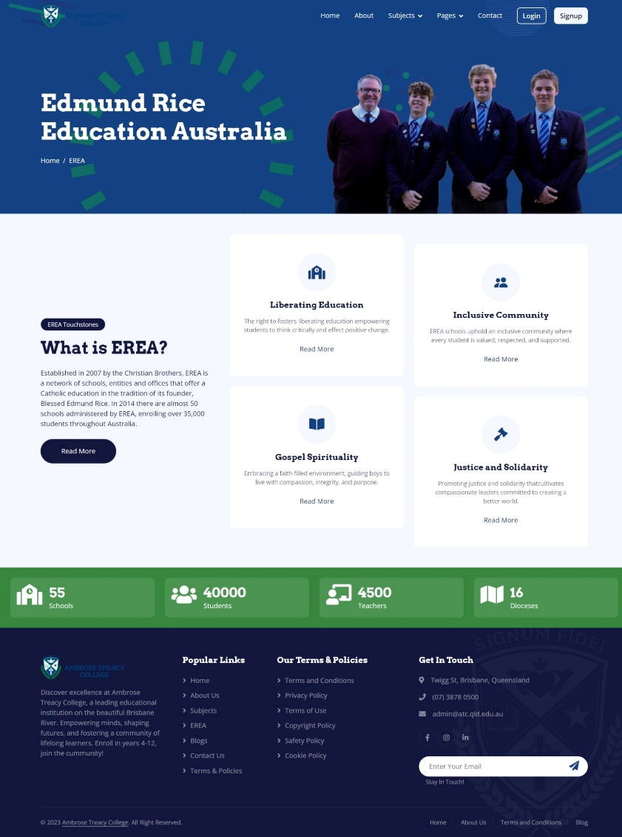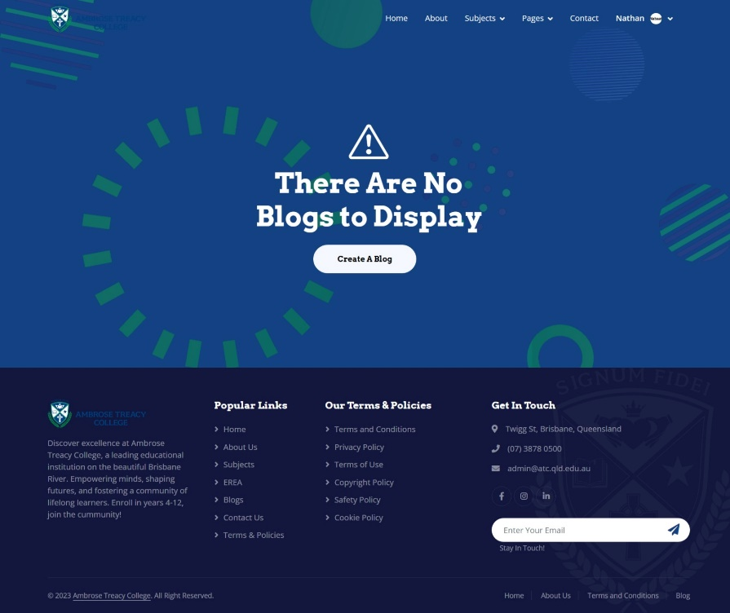

# Appendices

